Displaying Aircraft Movements and Positions in 3D Space

User Manual

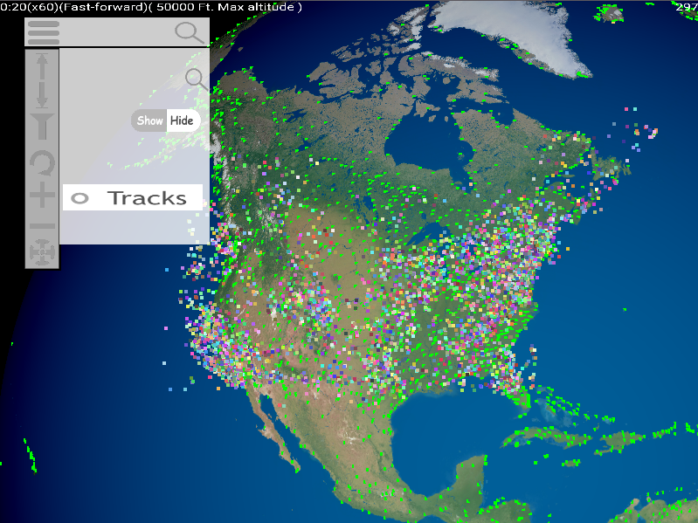

**User Manual**

**Overview**

This software is a flight path tracker that displays aircraft’s movements and positions in 3D space, according to the data file provided by the user.

**Run**

To run this software, download or clone it from the GitLab repository.

( <https://projects.cs.nott.ac.uk/Group20/Displaying-Aircraft-Movements-And-Positions.git>)

If downloaded from a zip, extract Displaying-Aircraft-Movements-And-Positions to a folder.

Then enter the Displaying-Aircraft-Movements-And-Positions folder.

For Windows users, run “airport-renderer-windows.exe” in “/bin/”.

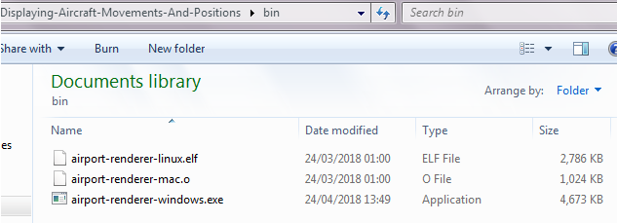

For Mac users, run “./bin/airport-renderer-mac.o” in terminal.



For Linux users, navigate to the bin folder, and run airport-renderer-linux.elf in a terminal.



**Loading**:

Upon launch, the user will be prompted to select which aircraft data file to load.

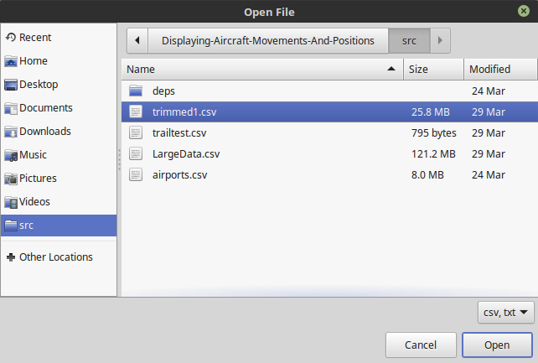

The program will then load the data (this may take a while depending on how large the file is, and the computer needs to have sufficient memory to load all the aircraft within at a time):

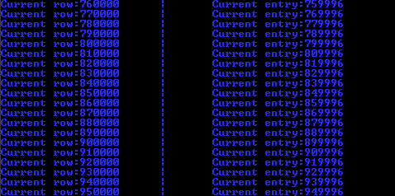

**Using the Program**:

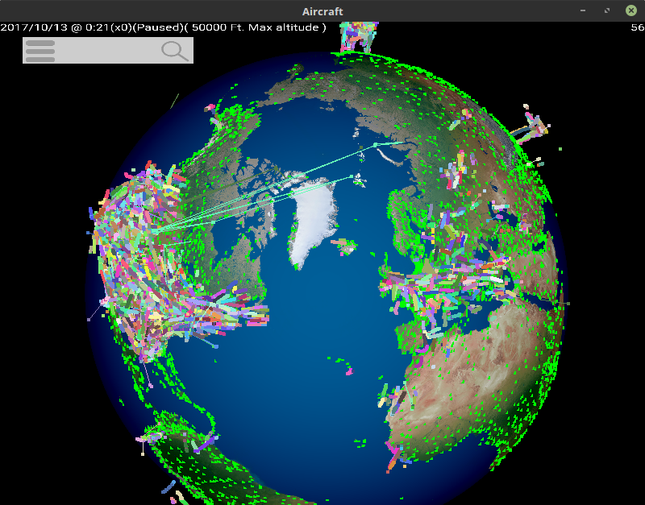

Top left text is as follows:

* year/month/day,
* hour:minute
* the speed of rendering
* whether it is going forward, reverse or it is paused
* the maximum altitude.

Top right text is the frames per second.

Airports are represented by green dots.

Different planes are represented by different coloured tracks.

Each track is all the aircraft data of a plane seen in the current minute of the hour, including their entire previous trails.

To move around the earth, click and drag the Left Mouse Button.

To rotate the camera’s perspective, click and drag the Right Mouse Button.

To zoom in or out, use the mouse scroll wheel. (see Menu Controls for an alternative method)

**Menu Controls**:

Click : to show additional options.

Click: and enter an aircraft ID to search for specific planes.

“ICAO” and “Call” values will be searched for. (See Aircraft file format)

**Altitude Height Control:**

Click : to increase maximum height to display aircraft.

Click : to decrease maximum height to display aircraft.

**Filters:**

Click : to display filter options, click again to hide filter page.

Click: to show or hide the tracks.

**Time Controls:**

Click: to display playback options, click again to hide playback page.

Click: to move forward in time.

Click: to move backward in time.

Click: to pause in time.

**Camera Controls:**

Click : zoom in.

Click: zoom out.

Click: to reset the camera.

**Aircraft file format**:

The file format for data to be loaded into the simulator is a Comma Seperated Values (CSV) file format, containing one header line, and multiple lines containing timestamps of a plane.

The following is a list of appropriate values for the header line, alongside how the data is used. All other values are ignored. If a required field is missing in a line, the entire line is ignored.

|  |  |  |
| --- | --- | --- |
| Field | Required? | Description |
| DateA | Yes | An integer describing the current date in the format YYYYMMDD, for example: 20171011 |
| TimeB | Yes | An integer describing the current time in the format HHmm, for example: 158 (for 1:50) or 4 (for 0:04). |
| Icao0 | No | A 6-digit hex number to identify an aircraft. For example: 06E00F |
| Lat3 | Yes | A floating point number describing the latitude of a plane at that point in time, for example: 48.059559 |
| Long4 | Yes | A floating point number describing the longitude of a plane at that point in time, for example: 2.12908 |
| GAlt2 | Yes | An integer describing the altitude of an aircraft in feet adjusted for local air pressure. For example: 39198 |
| Call5 | No | A string describing the “callsign” of an aircraft. For example: RWD701 |

**Examplefile:**

All greyed out fields exist within ‘trailtest.csv’, but are unused within the program. Thus allowing for easy conversion from multiple data sources if needed.

